NAME: S.VENIKALAXMI
REG NO:24MIS0117

Q1)ADDITION OF NUMBERS:

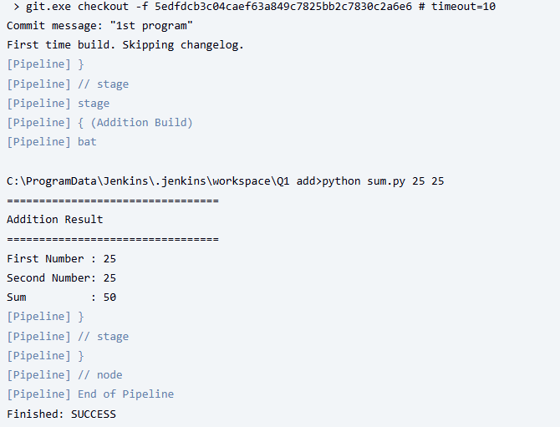

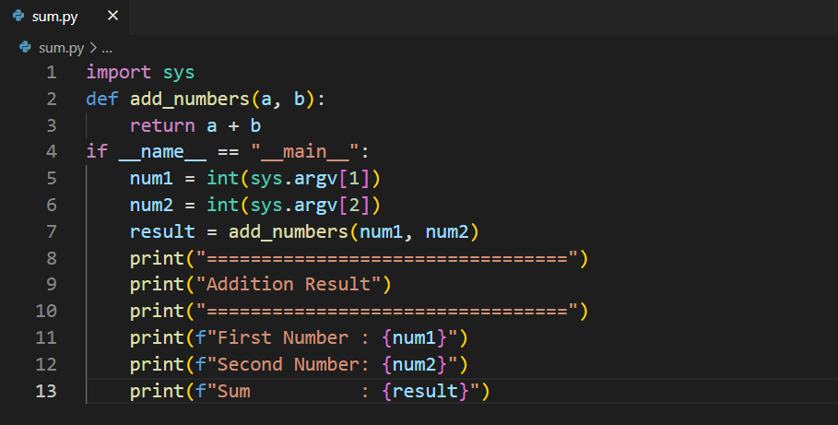
Pipeline code:
pipeline {
agent any
parameters {
string(name: 'BRANCH_NAME',
defaultValue: 'main',
description: 'Git branch')
string(name: 'NUM1',
defaultValue: '25',
description: 'First Number')
string(name: 'NUM2',
defaultValue: '25',
description: 'Second Number')
}
stages {
stage('Checkout') {
steps {
checkout scmGit(branches: [[name: '**']], extensions: [], userRemoteConfigs: [[url: 'https://github.com/venikalaxmisaravanan/sum.git']])
}
}

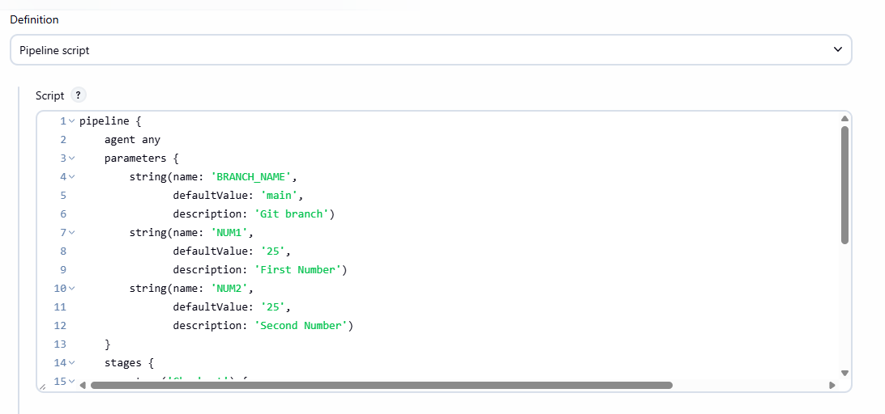

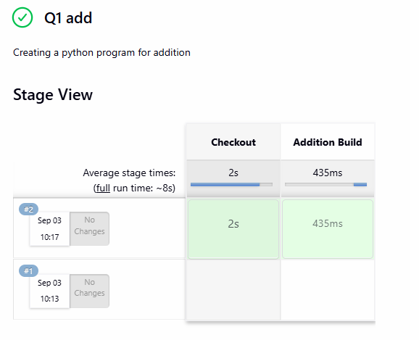

Q2)CALCULATOR
add:
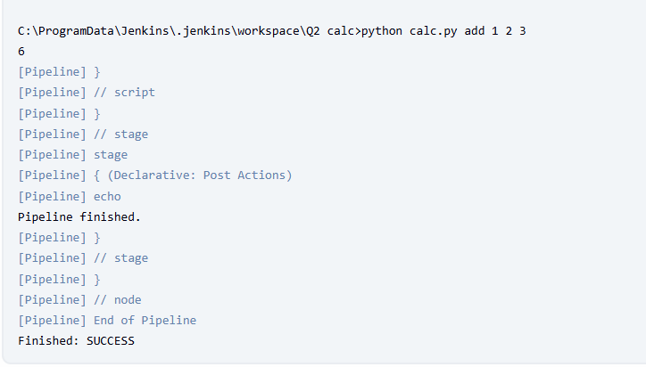
mul:

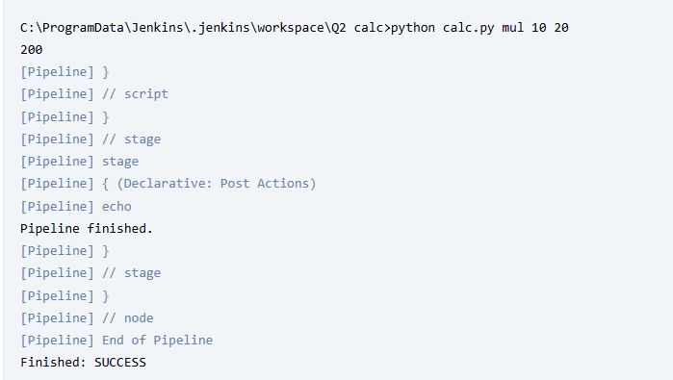
sub:

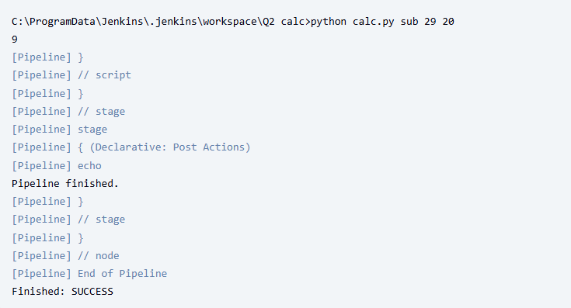
div:
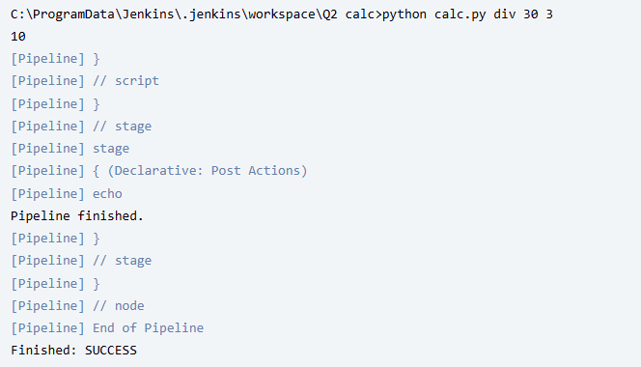
pipeline script:

pipeline {
agent any
parameters {
choice(name: 'OP', choices: ['add', 'sub', 'mul', 'div'], description: 'Operation to perform')
string(name: 'NUMS', defaultValue: '1 2 3', description: 'Space-separated numbers (e.g. "10 2 3")')
string(name: 'PRECISION', defaultValue: '', description: 'Optional: integer decimal places (leave empty for default)')
}
stages {
stage('Checkout Code') {
steps {
checkout scmGit(branches: [[name: '**']], extensions: [], userRemoteConfigs: [[url: 'https://github.com/venikalaxmisaravanan/Calculator.git']])
}
}
stage('Build') {
steps {
script {
// include precision flag only when provided
def prec = params.PRECISION?.trim() ? "-p ${params.PRECISION}" : ""
if (isUnix()) {
sh "python3 calc.py ${params.OP} ${params.NUMS} ${prec}"
} else {
bat "python calc.py ${params.OP} ${params.NUMS} ${prec}"
}
}
}
}
}
post {
always {
echo 'Pipeline finished.'
}
}
}

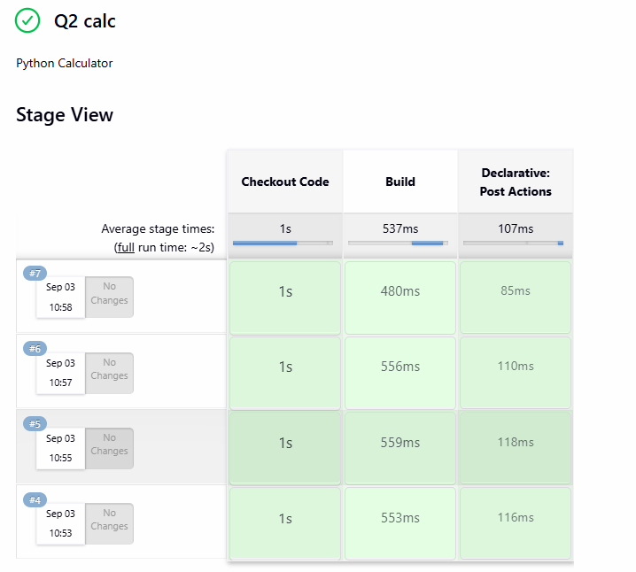
code in vs code:

#!/usr/bin/env python3
import argparse
import sys

def add(nums):
return sum(nums)

def sub(nums):
result = nums[0]
for n in nums[1:]:
result -= n
return result

def mul(nums):
result = 1.0
for n in nums:
result *= n
return result

def div(nums):
result = nums[0]
for n in nums[1:]:
if n == 0:
raise ZeroDivisionError("division by zero")
result /= n
return result

OPS = {
"add": add,
"sub": sub,
"mul": mul,
"div": div,
}

def format_result(res, precision):
if precision is not None:
return f"{res:.{precision}f}"
# If result is an integer value, show it as integer
if abs(res - round(res)) < 1e-12:
return str(int(round(res)))
return str(res)

def main():
parser = argparse.ArgumentParser(description="Simple CLI calculator")
parser.add_argument("op", choices=OPS.keys(), help="operation: add, sub, mul, div")
parser.add_argument("nums", nargs="+", type=float, help="numbers to operate on (space-separated)")
parser.add_argument("-p", "--precision", type=int, default=None, help="decimal places for output")
args = parser.parse_args()

if args.op in ("sub", "div") and len(args.nums) < 2:
parser.error(f"{args.op} requires at least two operands")

try:
result = OPS[args.op](args.nums)
except ZeroDivisionError as e:
print(f"Error: {e}", file=sys.stderr)
sys.exit(2)

print(format_result(result, args.precision))

if __name__ == "__main__":
main()

Q3)MARKS CALCULATION

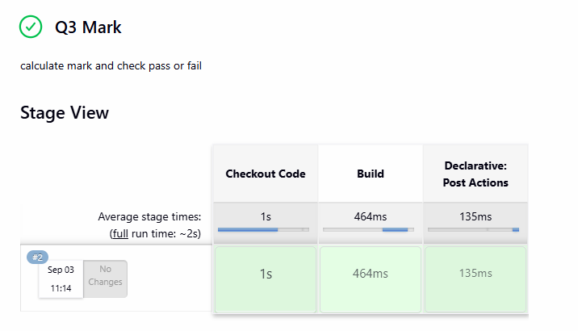
fail case:
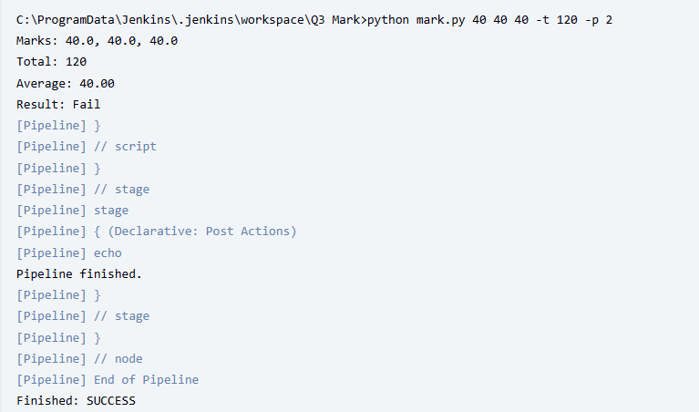

pass case:
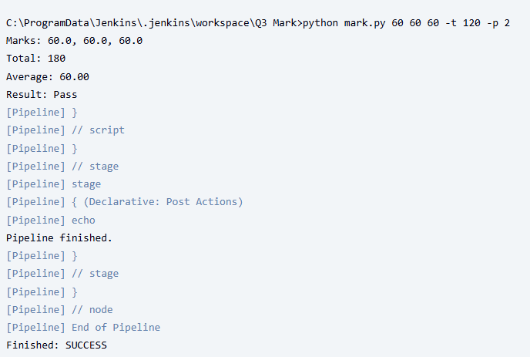

pipe line script:
pipeline {
agent any
parameters {
string(name: 'MARK1', defaultValue: '60', description: 'Marks for subject 1')
string(name: 'MARK2', defaultValue: '60', description: 'Marks for subject 2')
string(name: 'MARK3', defaultValue: '60', description: 'Marks for subject 3')
string(name: 'THRESHOLD', defaultValue: '120', description: 'Total pass threshold (numeric)')
string(name: 'PRECISION', defaultValue: '2', description: 'Decimal places for average')
}
stages {
stage('Checkout Code') {
steps {
checkout scmGit(branches: [[name: '**']], extensions: [], userRemoteConfigs: [[url: 'https://github.com/venikalaxmisaravanan/Marks-calculation.git']])
}
}
stage('Build') {
steps {
script {
// assemble argument string
def args = "${params.MARK1} ${params.MARK2} ${params.MARK3} -t ${params.THRESHOLD} -p ${params.PRECISION}"
if (isUnix()) {
sh "python3 mark.py ${args}"
} else {
bat "python mark.py ${args}"
}
}
}
}
}
post {
always {
echo 'Pipeline finished.'
}
}
}

code in vs code:
#!/usr/bin/env python3
import argparse
import sys

def parse_args():
p = argparse.ArgumentParser(description="Calculate total and average for 3 subjects")
p.add_argument("m1", type=float, help="Marks for subject 1")
p.add_argument("m2", type=float, help="Marks for subject 2")
p.add_argument("m3", type=float, help="Marks for subject 3")
p.add_argument("-t", "--threshold", type=float, default=120.0, help="Pass threshold for total (default: 120)")
p.add_argument("-p", "--precision", type=int, default=2, help="Decimal places for average (default: 2)")
return p.parse_args()

def validate_mark(name, v):
if v < 0:
raise ValueError(f"{name} must be non-negative")
return v

def main():
args = parse_args()
try:
m1 = validate_mark("m1", args.m1)
m2 = validate_mark("m2", args.m2)
m3 = validate_mark("m3", args.m3)
except ValueError as e:
print("Input error:", e, file=sys.stderr)
sys.exit(2)

total = m1 + m2 + m3
avg = total / 3.0

# print results
print(f"Marks: {m1}, {m2}, {m3}")
# show total as integer if it's an integer
if abs(total - round(total)) < 1e-12:
print(f"Total: {int(round(total))}")
else:
print(f"Total: {total}")

print(f"Average: {avg:.{args.precision}f}")

if total > args.threshold:
print("Result: Pass")
else:
print("Result: Fail")

if __name__ == "__main__":
main()

